- Data published around the turn of the year was consistent with the downbeat mood that characterised the latter months of 2025. We will publish our new UK forecast early next week, and this will show that we have cut our projection for GDP growth in 2026 to 0.9%, which is towards the bottom of the consensus.
- The public sector has stopped the recent performance of the economy from being even worse. Though state support will remain solid in 2026, we're gloomy about prospects for the private sector. Consumers are central to the story – though we expect them to adopt a less cautious attitude, this will likely be offset by a sharp slowdown in real income growth.
Data published either side of the Christmas break provided further evidence of the fragile state of private sector activity growth and offered little reason to be optimistic about the economy's growth prospects in 2026.
The Office for National Statistics published the Quarterly National Accounts for Q3 2025 shortly before the break. This confirmed that GDP rose by just 0.1% quarter-on-quarter in Q3, while very small revisions to prior quarters left the bigger picture largely unchanged. The expenditure breakdown was slightly less downbeat than before, with consumer spending growth in Q3 upgraded to 0.2% q/q, from 0.1% in the first estimate. Meanwhile, a string of upward revisions left the recent performance of business investment looking much healthier.
However, taking a step back and looking at the recent picture for GDP growth, it's clear that the economy's sluggish performance over the past three years would have been significantly worse were it not for the very strong contribution from the public sector. Since the end of 2022, GDP has risen by 2.4%, with government consumption and investment accounting for 1.7ppts of that increase (Chart 1). Current spending plans suggest that the public sector will continue to support the economy this year. But we're gloomy about the chances of the private sector providing a meaningful contribution, so we expect 2026 to be another challenging year for the UK economy.
Chart 1: GDP growth has been heavily reliant on the public sector in recent years
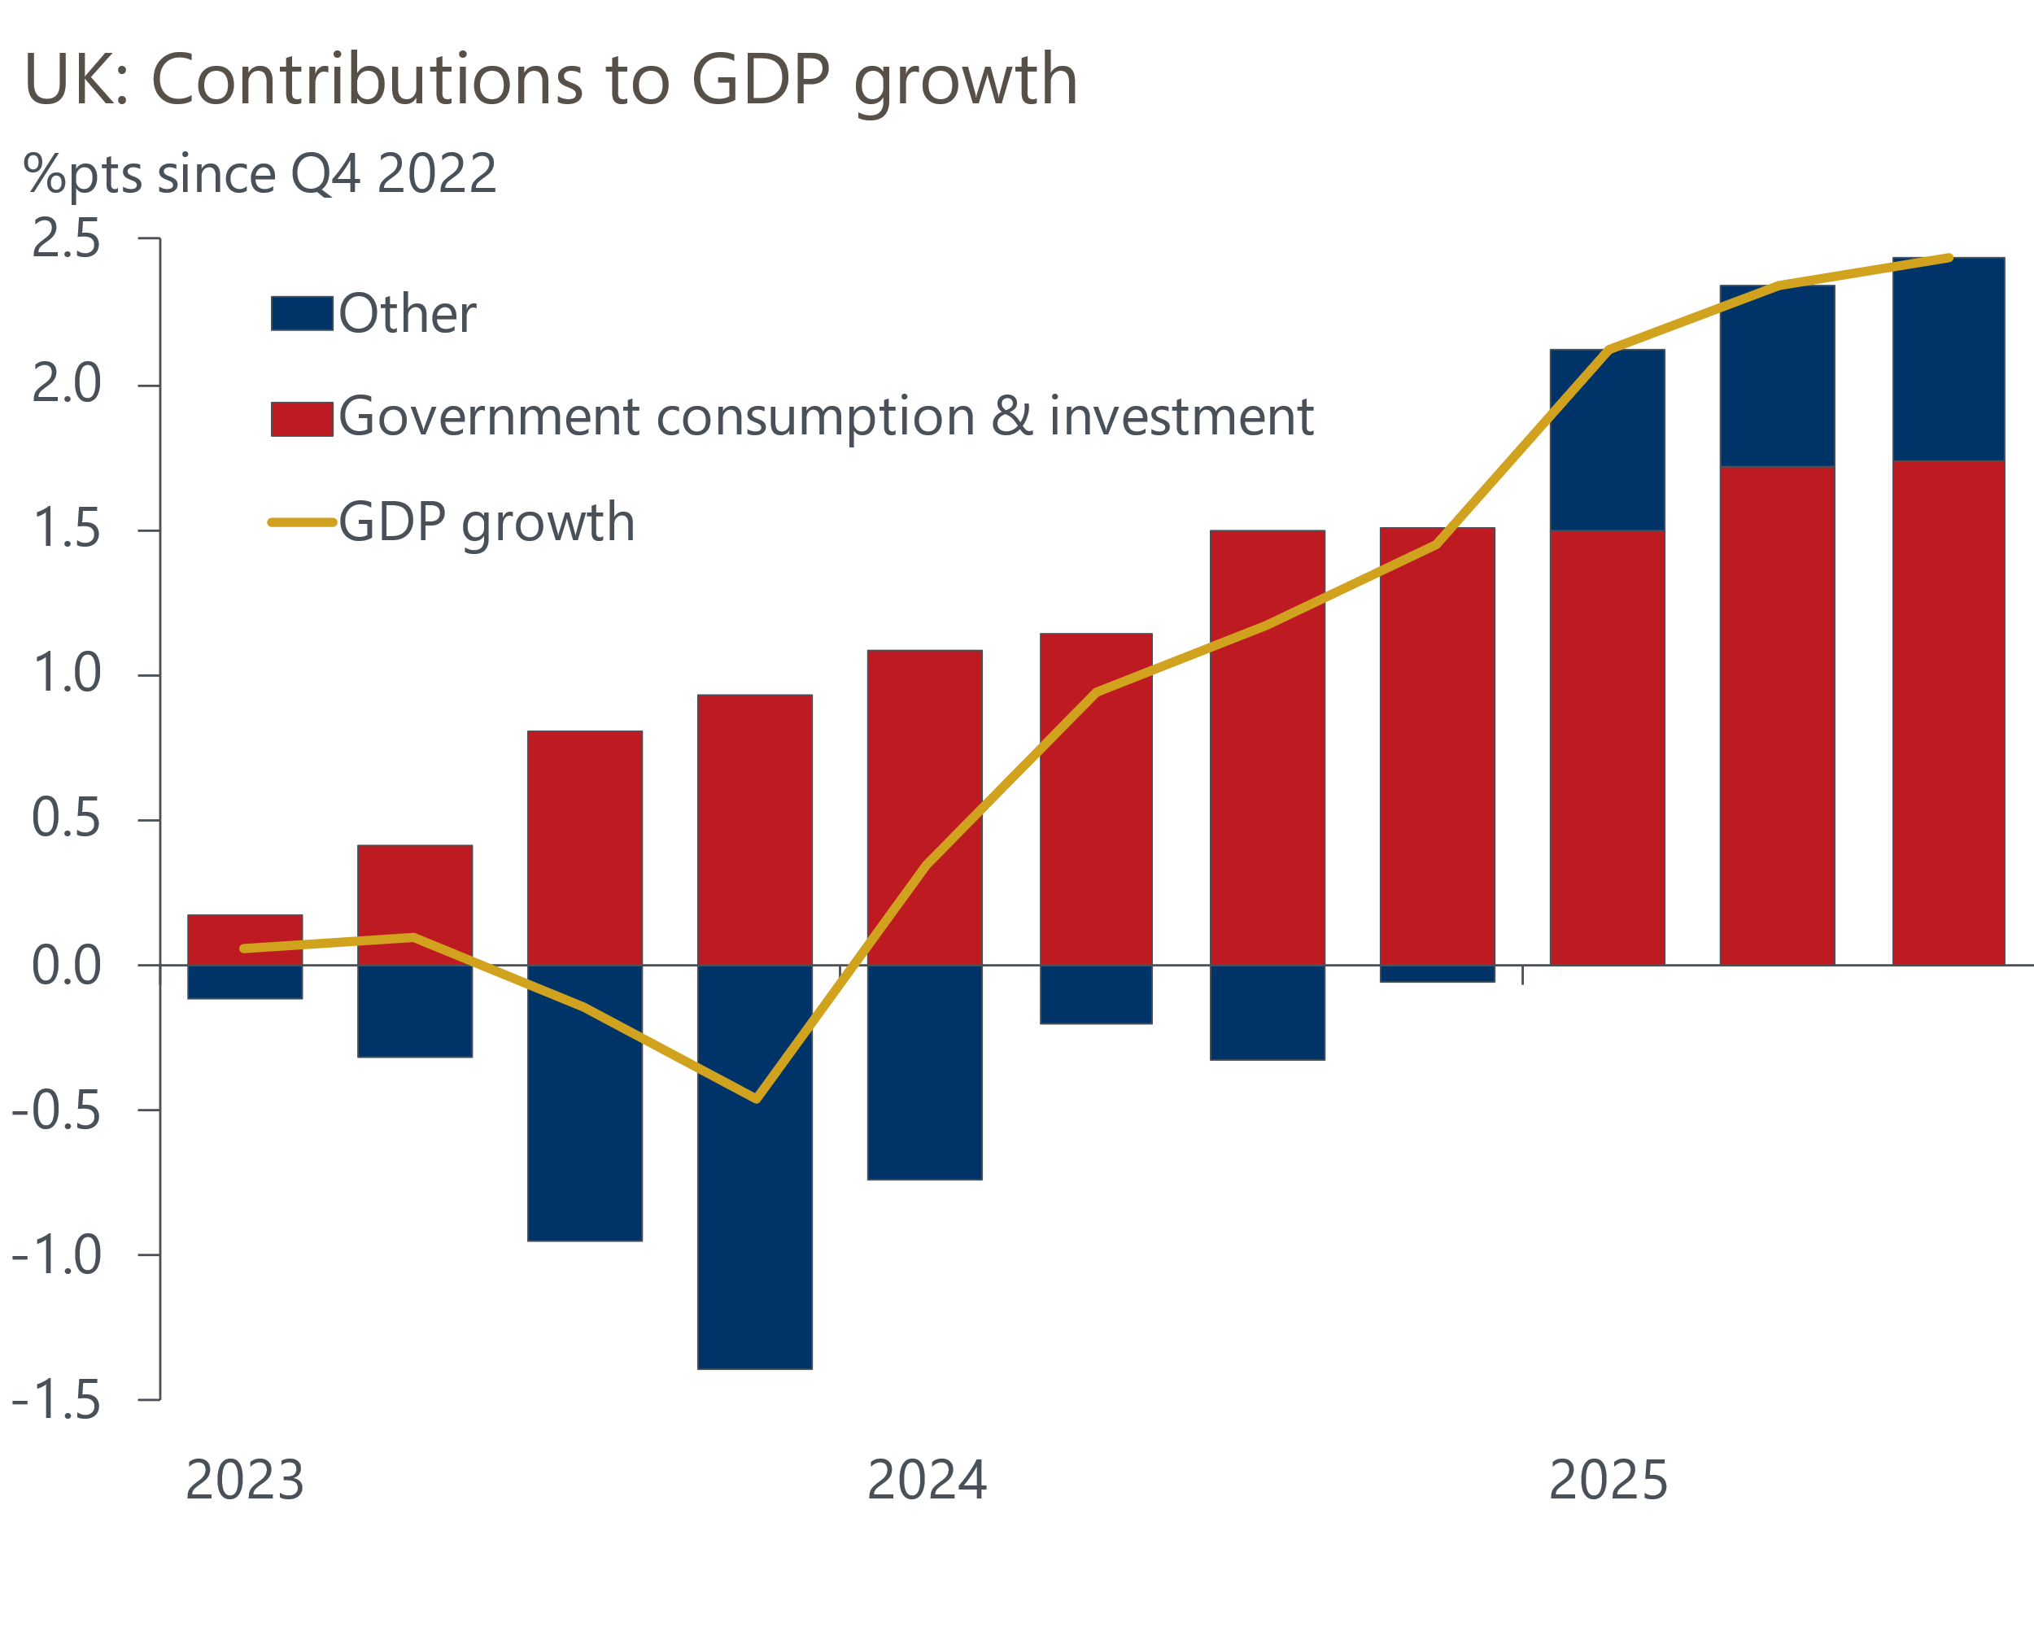
Sources: Oxford Economics calculations using Haver Analytics

This week's final S&P Global survey for December signalled that private sector output ended 2025 on a soft footing. The composite PMI rose only modestly to 51.4 in December, from 51.2 in November, remaining barely above the 50 'no-change' mark and much weaker than its long-run trend (Chart 2).
Chart 2: The composite PMI rose fractionally in December, and points to very modest GDP growth in Q4
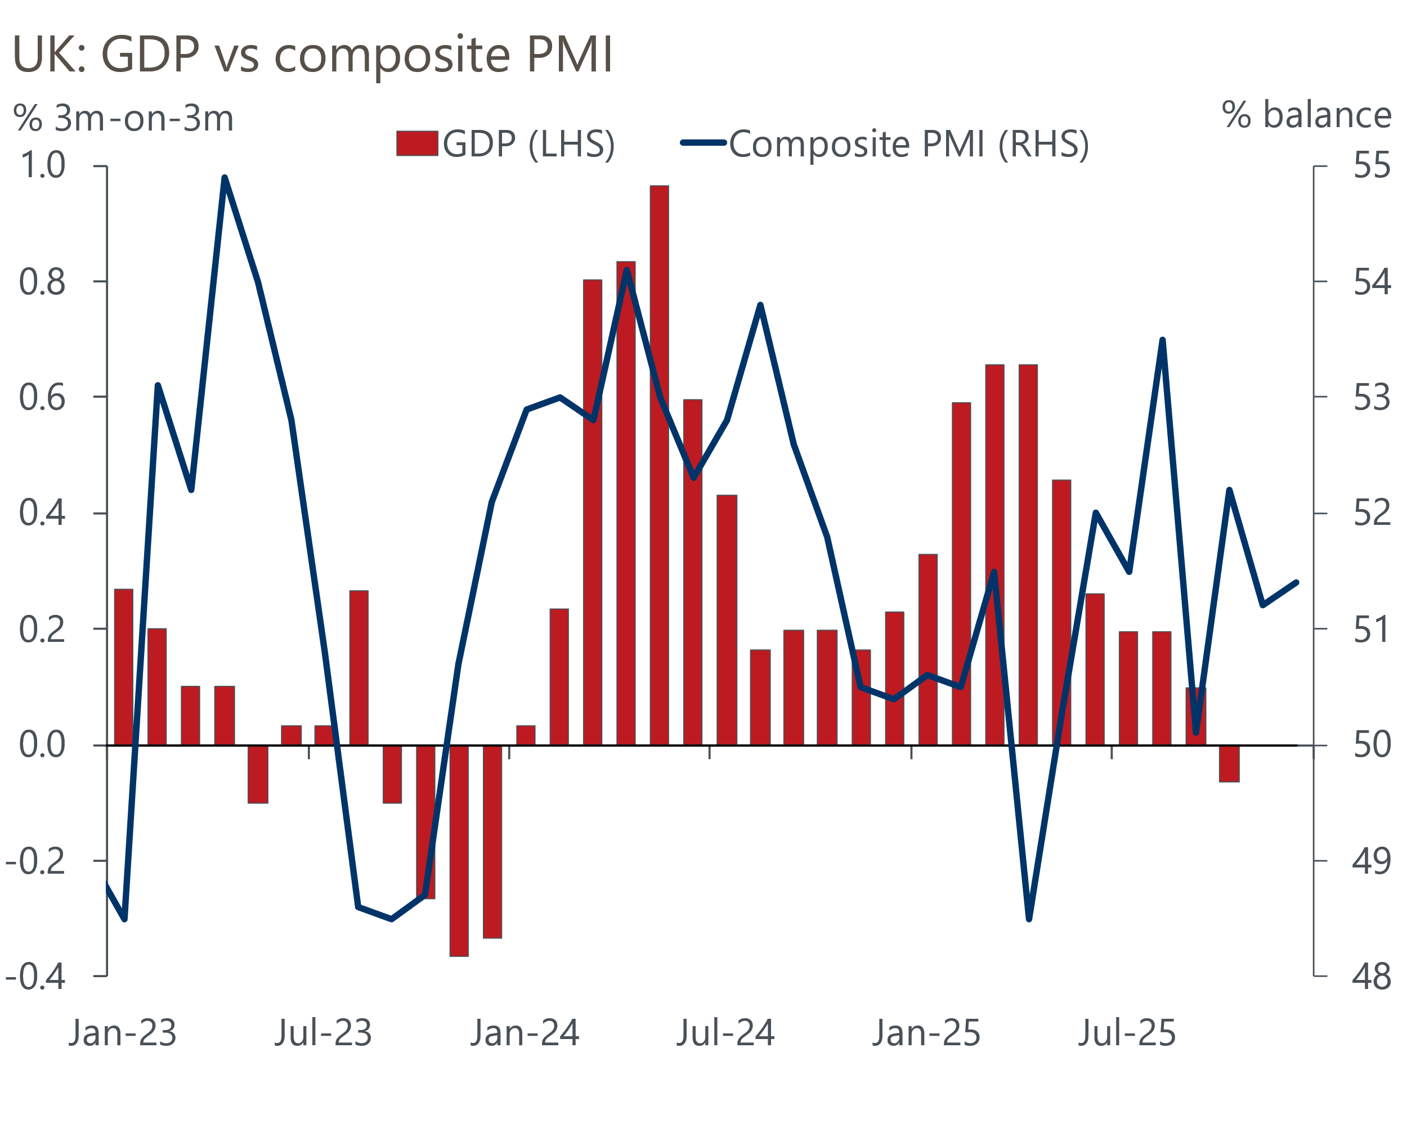
Sources: ONS, S&P Global
The survey also suggested that elevated cost pressures and squeezed margins led to further weakening in labour market conditions, though the pace of job losses did moderate slightly from November. This fragile picture was mirrored in the Bank of England Decision Maker Panel results for December, with firms reporting that employment continued to contract in the final three months of last year.
Together with the disappointing monthly official output data for October, this week's underwhelming survey data reinforces our view that official GDP growth remained very sluggish in Q4 2025. This should provide a relatively weak launchpad for growth this year.
Consumers will be the key to whether we see an improvement in private sector activity growth this year. Although households have enjoyed a strong recovery in their spending power since the energy crisis began to ease, they have behaved very cautiously, saving a high proportion of their income and showing meagre demand for credit amid signs of heightened financial insecurity.
But the momentum behind real income growth has already begun to slow, and we expect this to continue through 2026. As the labour market loosens, pay growth is slowing sharply, and surveys suggest the new year pay round will result in lower settlements than last year. So though we expect a more benign year for inflation, real wage growth is likely to be much weaker. Policy settings will also weigh on income growth. The ongoing freeze in most allowances and thresholds will ensure that income tax and national insurance payments continue to rise strongly. On the monetary side, though we anticipate further cuts to Bank Rate, net interest income will increasingly drag on household incomes in the near term. This is because the returns on household savings will fall back in response to further cuts to Bank Rate, while a sizeable minority of mortgagors still need to refinance cheap fixed-rate mortgage deals taken out before mid-2022
There is scope for households to mitigate the impact of weaker income growth by saving less. Sentiment surveys continue to firm, and this week's BoE Money & Credit release showed tentative signs that consumers' appetite for credit is rising. Therefore, although consumer spending is likely to remain in a low gear this year, we think it will likely outperform improvements in spending power.
The outlook for the company sector is similarly subdued. Corporate profitability remains at a 20-year low, and when coupled with fragile business confidence, elevated trade policy uncertainty, and soft consumer demand, this suggests the recent improvement in business investment is unlikely to be sustained this year.
We will publish our new forecast as part of our global forecast update on January 13. This will show that our projection for 2026 GDP growth has been cut to 0.9%, which is towards the bottom of the consensus.

The week ahead
Next week's only major release is the GDP data for November. Recent releases have underwhelmed, with GDP falling by 0.1% month-on-month in both September and October. We've seen GDP growth slow in Q3 in each of the past four years, which lends support to the argument that the data may be suffering from residual seasonality issues. But activity has then tended to pick up through Q4, so there are grounds to expect some recovery in growth through the final months of last year.
At the sector level, although October's GDP reading disappointed, it was driven by unusually weak readings across a wide range of services sub-categories. There's a good chance that such moves unwound in November. Meanwhile, activity in the manufacturing sector is likely to have expanded again, as the phased restart in the automotive supply-chain continued, following September's cyber-attack. Overall, we think these forces mean GDP rose 0.1% m/m in November.
Table 1: Week ahead calendar
Date | Events | Period | Measure | Unit | Previous | Forecast
Jan 15 | GDP | Nov | m/m | % | -0.1 | 0.1
Jan 15 | GDP | Nov | 3m/3m | % | -0.1 | 0.0
Jan 15 | Index of services | Nov | m/m | % | -0.3 | 0.1
Jan 15 | Index of services | Nov | 3m/3m | % | 0.0 | 0.1
Jan 15 | Manufacturing output | Nov | m/m | % | 0.5 | 0.7
Jan 15 | Manufacturing output | Nov | y/y | % | -0.8 | 0.8
Jan 15 | Industrial production | Nov | m/m | % | 1.1 | 0.2
Jan 15 | Industrial production | Nov | y/y | % | -0.8 | 1.3
Jan 15 | Construction output | Nov | m/m | % | -0.7 | 0.3
Jan 15 | Construction output | Nov | y/y | % | 0.9 | 1.0
Jan 15 | UK trade | Nov | Trade balance | £bn | -4.8 | -2.4
Jan 15 | UK trade | Nov | Visible balance | £bn | -22.5 | -20.4
Source: Oxford Economics

Key forecasts
Table 2: UK forecast overview
(Annual percentage changes unless specified)
 | 2023 | 2024 | 2025 | 2026 | 2027 | 2028
GDP | 0.3 | 1.1 | 1.4 | 0.9 | 1.4 | 1.5
Private consumption | -0.3 | -0.1 | 0.9 | 1.1 | 1.1 | 1.4
Fixed investment | 0.5 | 1.7 | 3.2 | 0.9 | 2.1 | 2.1
Government consumption | 2.1 | 2.9 | 1.8 | 2.1 | 1.7 | 1.4
Exports of goods and services | -2.3 | 1.4 | 2.3 | 0.6 | 1.0 | 1.3
Imports of goods and services | -1.6 | 2.7 | 4.0 | 0.2 | 1.2 | 1.4
Industrial production | -2.6 | -1.3 | 0.1 | -0.5 | 1.1 | 1.1
Consumer prices | 7.3 | 2.5 | 3.4 | 2.5 | 2.5 | 2.3
Unemployment rate (%) | 4.1 | 4.3 | 4.8 | 5.2 | 5.0 | 4.7
Current a/c balance (% of GDP) | -3.6 | -3.0 | -2.6 | -2.6 | -2.5 | -2.4
Government balance (% of GDP) | 5.2 | 5.3 | 5.0 | 3.8 | 3.3 | 2.8
Central bank policy rate (%, EOP) | 5.25 | 4.75 | 3.75 | 3.25 | 3.00 | 2.75
10yr govt. bond yield (%, EOP) | 3.54 | 4.57 | 4.47 | 4.40 | 3.90 | 3.64
Exchange rate (US$ per £, EOP) | 1.27 | 1.25 | 1.35 | 1.29 | 1.29 | 1.29
Exchange rate (euro per £, EOP) | 1.15 | 1.21 | 1.15 | 1.11 | 1.11 | 1.11
Source: Oxford Economics
Table 3: Quarterly forecasts for the UK
 | 2025 |  |  |  | 2026
 | Q1 | Q2 | Q3 | Q4 | Q1 | Q2 | Q3 | Q4
GDP (% year) | 1.8 | 1.4 | 1.3 | 1.1 | 0.7 | 0.7 | 0.9 | 1.2
CPI inflation (% year) | 2.8 | 3.5 | 3.8 | 3.5 | 3.2 | 2.1 | 2.2 | 2.3
Bank Rate (%, EOP) | 4.50 | 4.25 | 4.00 | 3.75 | 3.75 | 3.50 | 3.50 | 3.25
10yr gilt yield (%, EOP) | 4.70 | 4.48 | 4.70 | 4.47 | 4.60 | 4.55 | 4.49 | 4.40
US$ per £ (EOP) | 1.29 | 1.37 | 1.35 | 1.35 | 1.30 | 1.29 | 1.29 | 1.29
Euro per £ (EOP) | 1.20 | 1.17 | 1.15 | 1.15 | 1.12 | 1.11 | 1.11 | 1.11
Source: Oxford Economics

Latest Country Economic Forecast:
December 10, 2025

Recent publications

Data Insights
Disappointing services PMI reading rounds out 2025
Mortgage activity plateaus as affordability gains start to fade
Manufacturing PMI reports a fractional improvement in activity
National Accounts highlight the fragile state of the economy
Public finances remain on a difficult path

Research Briefings
Why higher term premia will slow the fall in gilt yields
MPC cuts, but emphasises the need for caution in 2026
MPC preview – Close call, but probably a cut
Why are household savings higher? Evidence from microdata
Key themes 2026 – Sluggish growth and fiscal worries

Contacts

Oxford Economics' UK team
- Andrew Goodwin - Chief UK Economist - agoodwin@oxfordeconomics.com
- Edward Allenby - Senior UK Economist - eallenby@oxfordeconomics.com

